**Version Control Systems**

* This is source code repository
* Software which allows us to store code along with history is called as Version Control Systems.
* Evolution of VCS
  + Single System VCS
  + Client Server VCS: Popular examples are Subversion, Clear Case, Visual Source Safe etc
    - Online
    - Offline

Distribute Version Control Systems: Mercurial, Git   
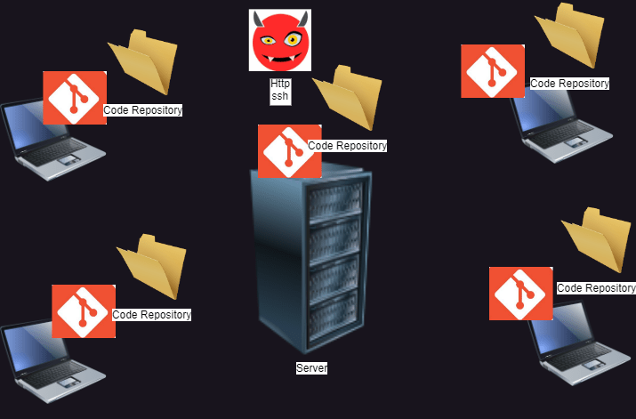

**Git**

* In Git we have 5 areas
  + Working tree/directory
  + Staging area/Cache area
  + Local repository
  + Remote Repository
  + Stash

Let’s focus on 3 areas  
  
